- Which command displays the MySQL version?
SELECT version();
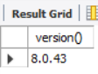
- Use the SELECT command to evaluate 4 × 4 × 4 and name the column Cube of 4.
SELECT (4 * 4 * 4) AS `Cube of 4`;
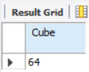
- Display your name with SELECT.
SELECT 'Brendon Flores' AS Name;
